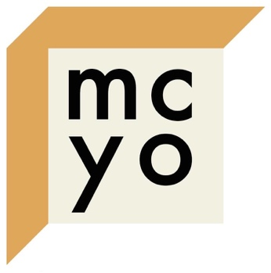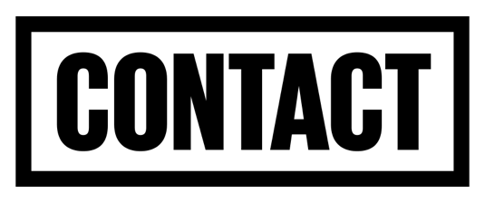**SUPPORTED BY**

**AND THE HENFREY CHARITABLE TRUST**

**PARTICIPANT APPLICATION FORM**

**Manchester Contemporary Youth Opera 2025**

*If you need help completing this form, please email mcyopera@gmail.com.*

**Name:**

**Prefer to be known as:**

**Pronouns:**

**Address:**

**Email:**

**Mobile:**

**Link to application video[1]:**

**What skills can you bring?:**

**Why are you interested in participating?:**

**How would you approach working collaboratively?:**

**I confirm that I am happy for the above information to be circulated to other participants, mentors and MCYO Artistic Directors & staff if selected:**

YES/NO

Please note any exceptions or concerns here:

**I confirm that I am happy for any work created by me and my team on the MCYO 2024 project to be filmed and shared online by MCYO:**

YES/NO

Please note any concerns here:

**I commit to interacting with others positively, and to pursue all creative work as a committed team player:**

YES/NO

**I am available to participate on the key dates stated below, and will work to deadlines set by MCYO:**

YES/NO

Please note any exceptions here:

**I will engage with social media activities throughout the project:**

YES/NO

Please note any concerns here:

Please follow/like us on Facebook/Instagram if possible: @mcyopera

**Please note any social media handles/websites here:**

**Please note any food allergies, intolerances, or dietary requirements here:**

**Please inform us (confidentially) of any medical conditions and medications of which we should be aware during the course:**

**Emergency contact:**

**Project dates:**

**Tuesday 26 August to Friday 29 August 2025**

Week 1, working at Contact daily 10am-6pm. (12pm start on day 1.) [And some different workshop venues on Friday 29 August.]

**Saturday 30 August and Sunday 31 August 2025**

No scheduled activity, though we anticipate participating artists will continue working independently. Please keep the weekend free to allow for this as well as some rest time.

**Monday 1 September to Thursday 4 September 2025**

Week 2, working at Contact [and some additional local venues] daily 10am-6pm.

**Friday 5 September 2025**

Filming and performance day at Contact. Expected hours 11am-10pm (including get-out and post-performance social).

Please be aware that you may have creative tasks to undertake outside of these specified hours. We recommend that you plan accordingly for this!

**Venue address: Contact Theatre, Oxford Rd, Manchester M15 6JA**

1. A 1-minute video of you sharing imaginative original work that shows what you could contribute to the collaboration.

   The video could be shot on your phone. Please let us know if you need to submit in a different format (e.g. audio/written) by emailing mcyopera@gmail.com.

   Your video should be sent as a link, rather than as a file (e.g. upload it to YouTube as ‘unlisted’).